**CREATION OF IBM WATSON, IOT PLATFORM AND DEVICE**

Date 3 November 2022

Team ID PNT2022TMID37462

Project Name Industrial Specific Fire Alarm System

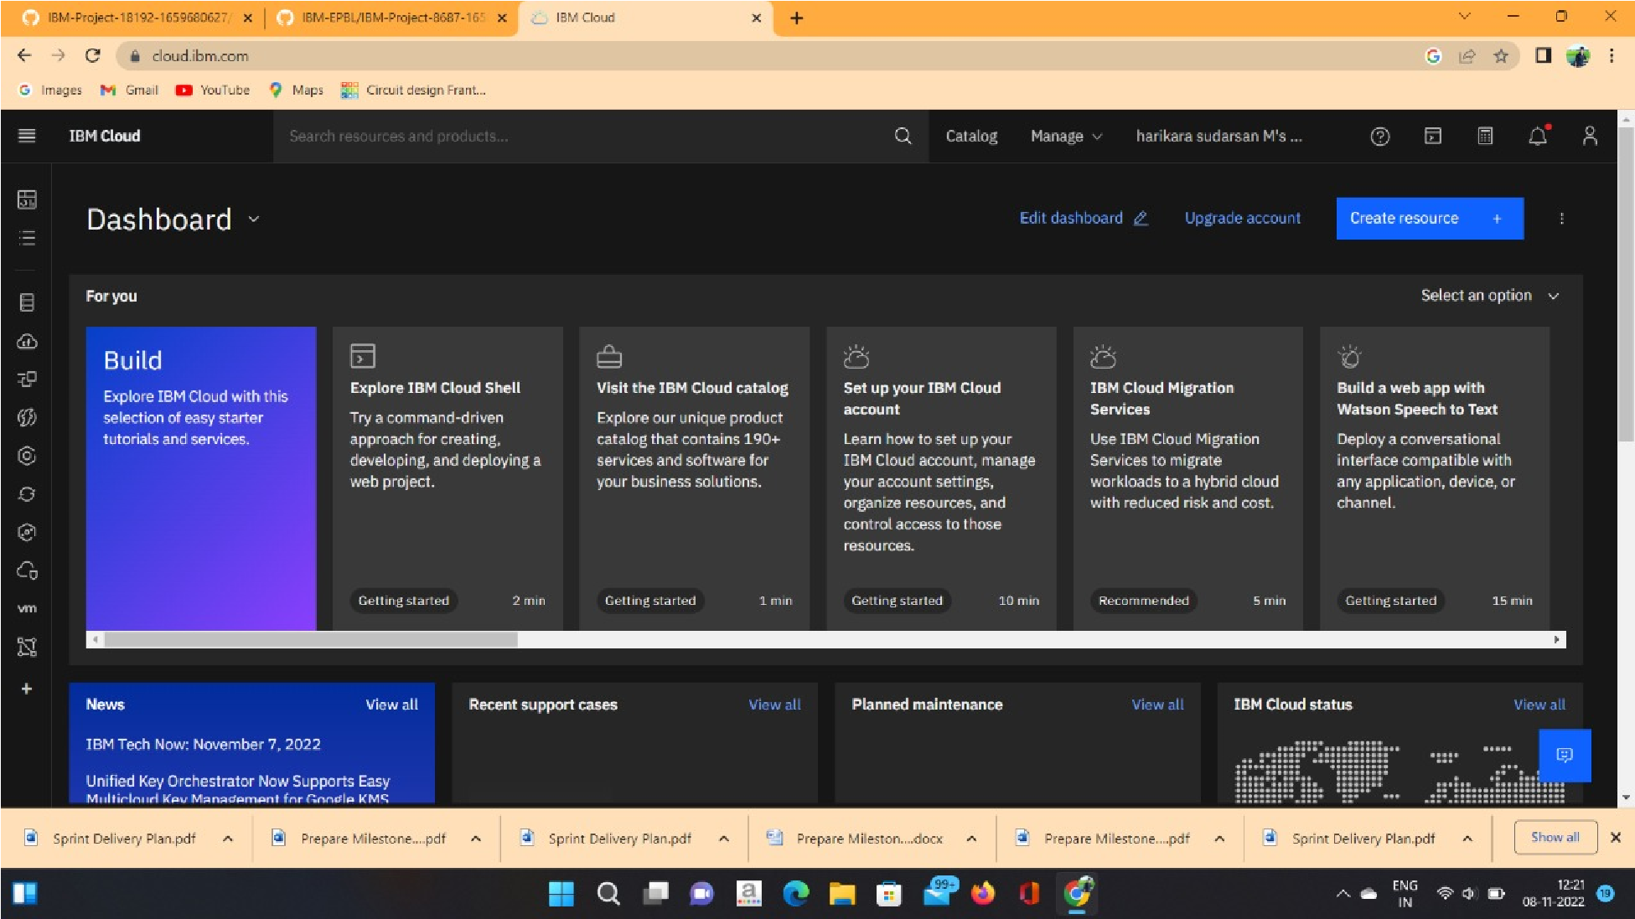

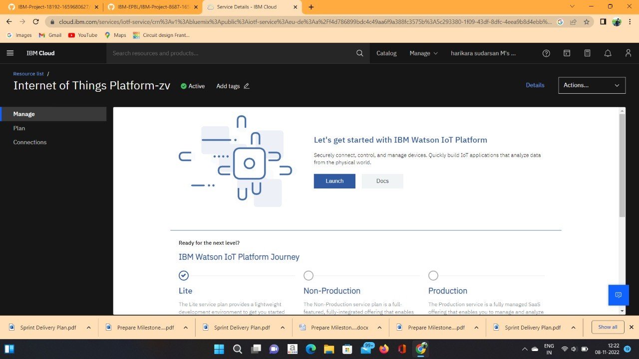

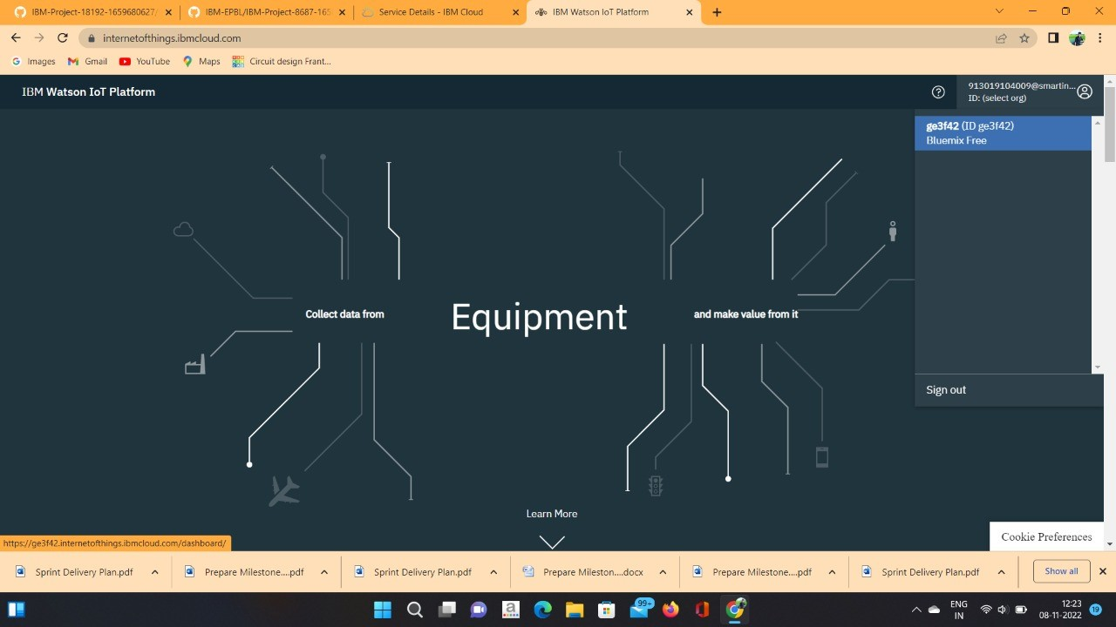

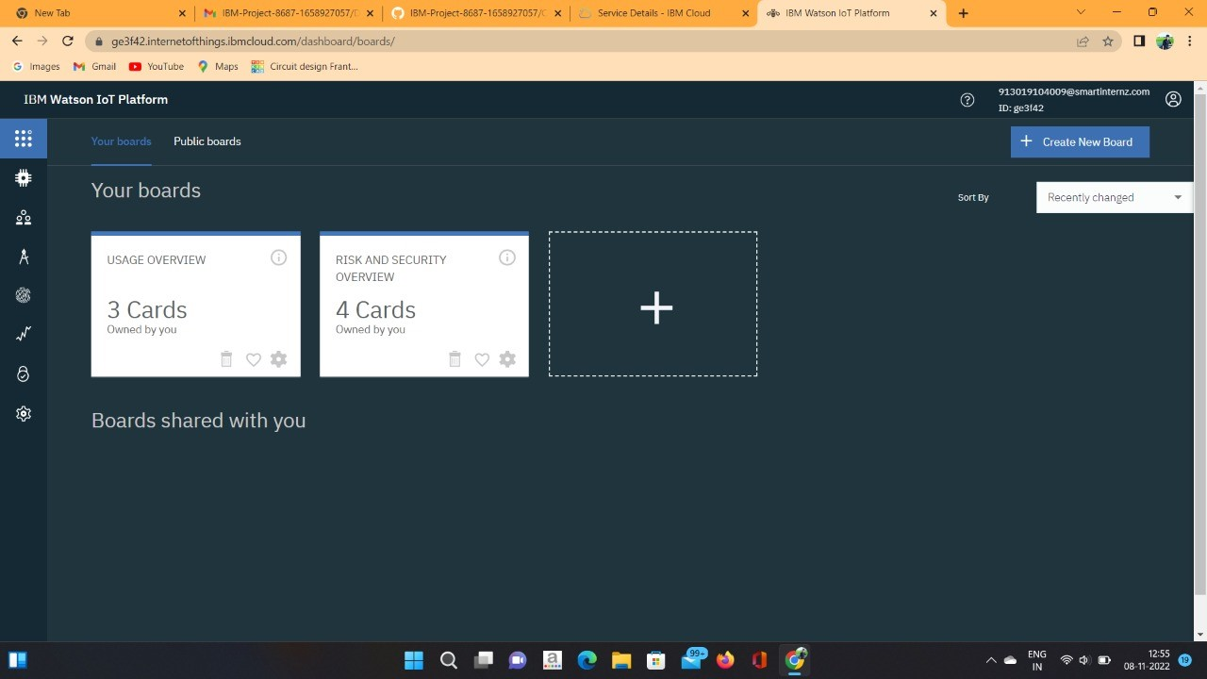

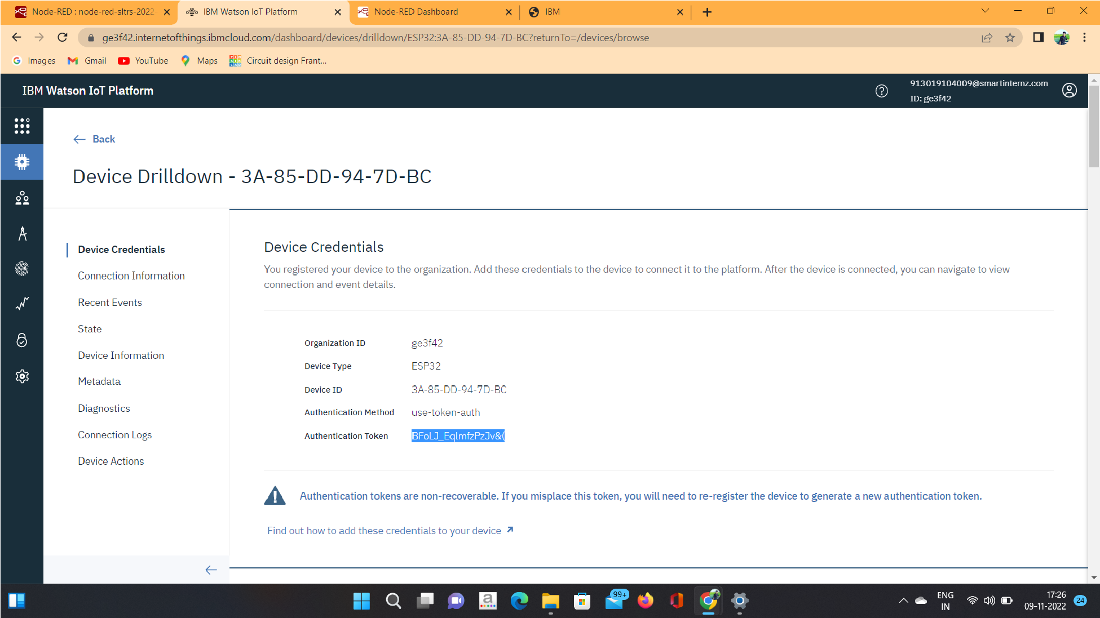

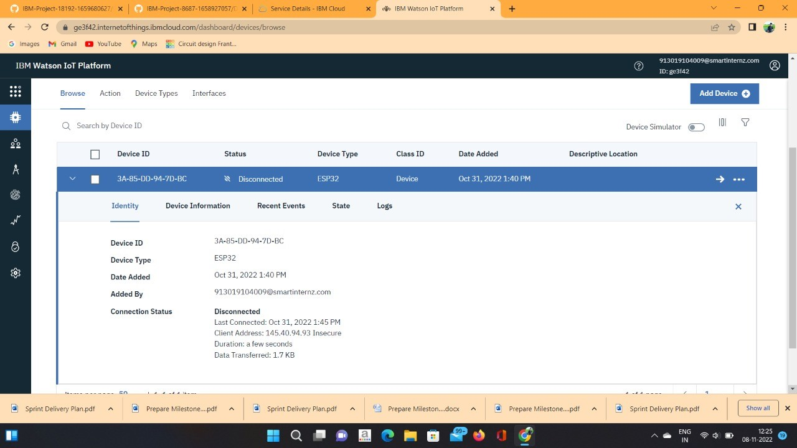

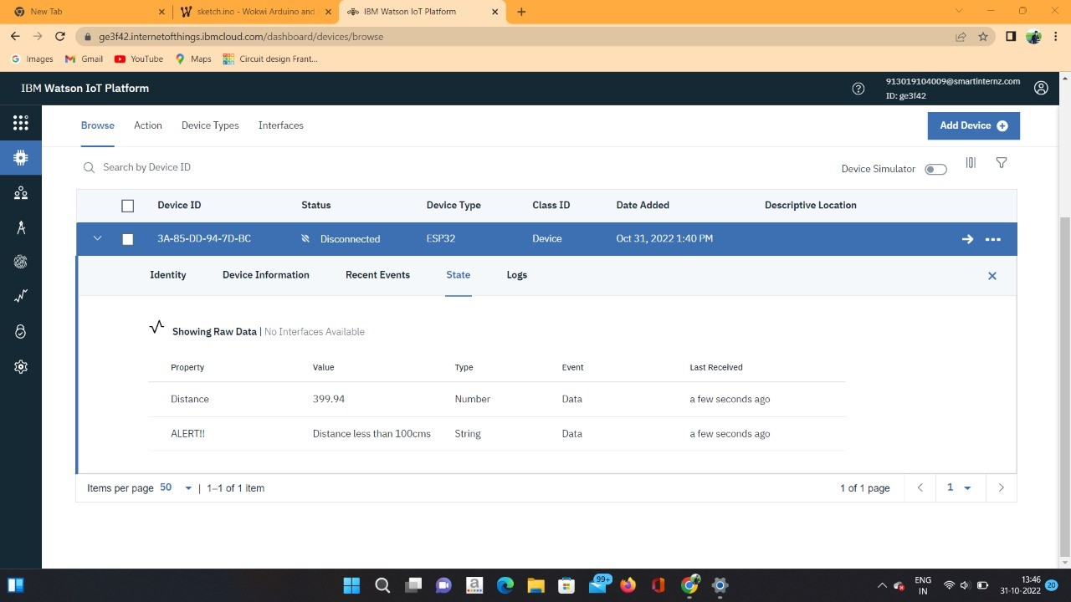

**RESULT:**

An IBM Watson cloud for IoT and a device is created successfully.